**29. Design DFA using a simulator to accept the input string “bc” ,”c”,and ”bcaaa”.**

**AIM:** To design DFA using a simulator to accept the input string “bc” ,”c”,and ”bcaaa”.

**TRANSITION DIAGRAM:\**

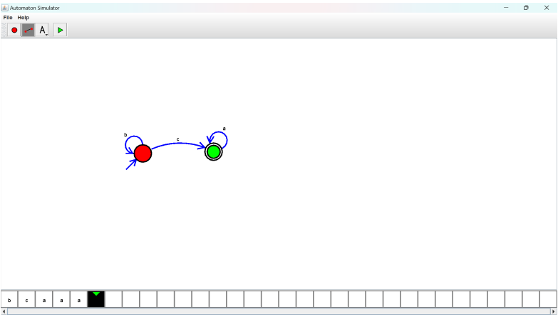

**RESULT:** Hence designing DFA using a simulator to accept the string “bc” ,”c”,and ”bcaaa”